Lab Logbook – Cyber Security and AI Cases Studies

Lab 1:
- DataFrame – The DataFrame class represents a 2-dimensional labeled table, making it the most commonly used structure for working with datasets in Pandas.

- Series – The Series class is a 1-dimensional labeled array that is ideal for handling single columns of data or time-based values.

- Index – The Index class provides immutable labels for rows or columns, helping Pandas align and organize data efficiently.

- Timestamp – The Timestamp class is used for working with individual date and time values, especially in time series analysis.

- Categorical – The Categorical class stores data with a fixed set of categories, improving memory usage and performance for repeated values.

Lab 2: Twitter Bitcoin Scam (2020)
Reference link: How the Alleged Twitter Hackers Got Caught | WIRED

The Twitter Bitcoin scam attack involved a coordinated effort by attackers to compromise high-profile Twitter accounts and deceive followers into sending cryptocurrency payments.

Spear Phishing: The attackers employed sophisticated spear phishing techniques to gain unauthorized access to Twitter’s internal tools.

After an investigation that included the FBI, IRS, and Secret Service, the Department of Justice charged UK resident Mason Sheppard and Nima Fazeli, of Orlando, Florida in connection with the Twitter hack.

Lab 3:
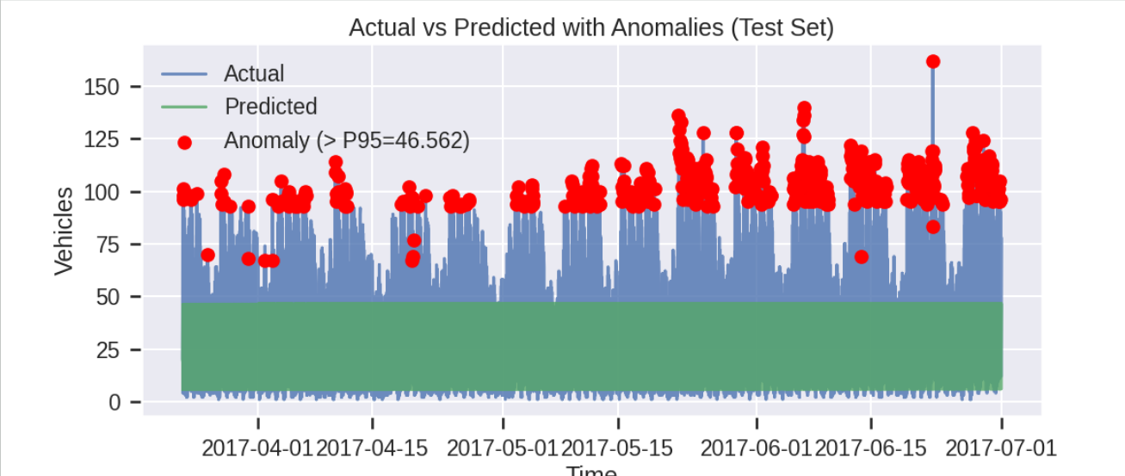

Lab 4:
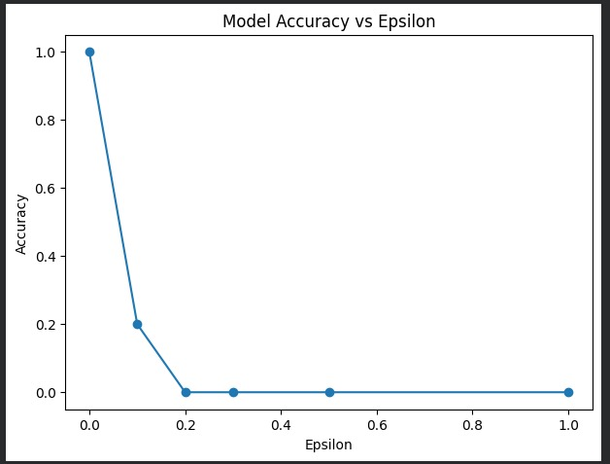

Lab 5:


Lab 6:
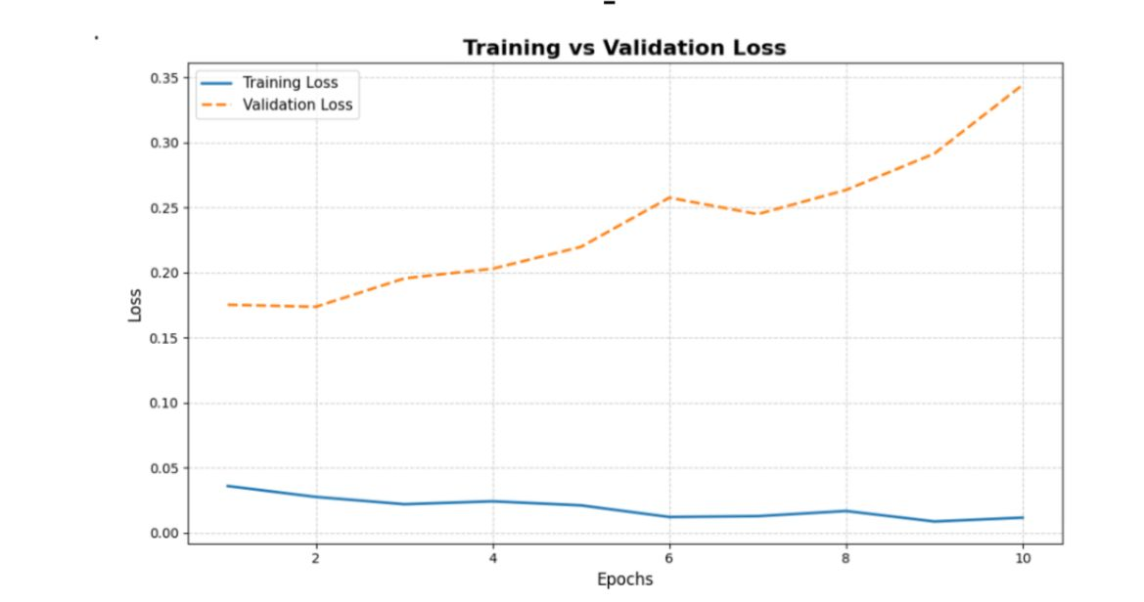

Lab 7:


Lab 8:
RSA:
p=3, q=11
n=p×q=3×11=33
ϕ(n)=(p−1)(q−1)=(3−1)(11−1)=2×10=20
e=3 (must be coprime with 20)
D⋅e≡1mod 20
3×7=21≡1mod20
So,
d=7d = 7d=7
Public Key : (e,n)= (3,33) (e, n) = (3, 33) (e,n)= (3,33)
Private Key : (d,n)= (7,33) (d, n) = (7, 33) (d,n)= (7,33)

Task 2: Encrypt a Message
M=5
C=Me mod n
C=5³ mod 33= 125 mod 33=26
Encrypted Message:
C=26

Task 3: Decrypt the Message
M=Ce mod n
M=26⁷ mod33

Step-by-step (simplified):
- 26² mod 33=16
- 26⁴ mod 33=25
- 26⁷=26⁴⋅26²⋅26 mod 33
- =25⋅16⋅26mod33
- =5
Decrypted Message:
M=5

Diffie Hellman:
p=23
g=5

Private key:
A = 5
B = 15

A = gª mod p
A=5⁶ mod 23
- 5²=2⁵ mod 23=2
- 5⁴=2²=4 mod 23
- 5⁶=5^{4⋅}5²=4⋅2=8 mod 23

A = 8

Partner’s Public Key:
S=Bª mod p

Calculation:
S=19⁶ mod 23

19²=361 mod 23=16
19⁴ = 162 = 256 mod23 = 3
19⁶ =19⁴⋅19²=3⋅16=48 mod 23=2

S = 2

Lab 9:
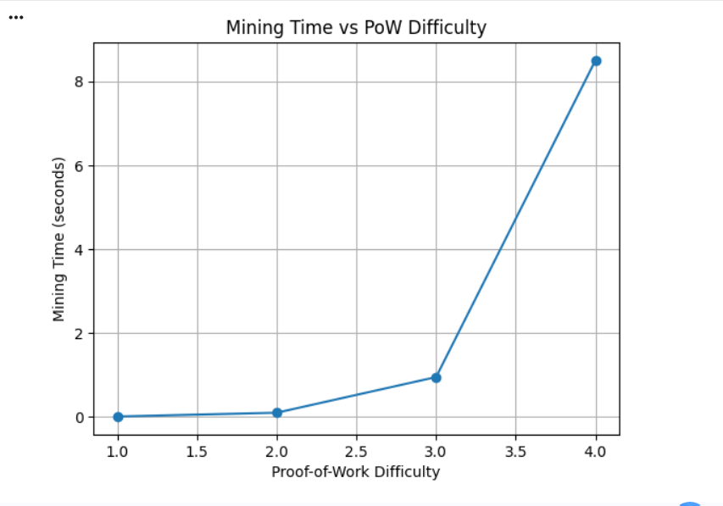

Lab 10:
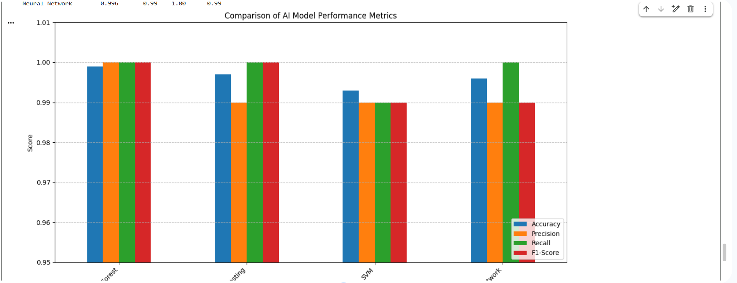

Github: https://github.com/nihardave25/Cyber-Security-AI-Cases.git

